**Ivancich Stefano 1227846**

**Neural Network and deep learning course 2020/21**

**Homework 2**

**Introduction**

explain the homework goals and the main implementation strategies you choose,

**Method**

describe your model architectures and hyperparameters

**Result**

present the simulation results.

* 1 pt: implement and test (convolutional) autoencoder, reporting the trend of reconstruction loss and some examples of image reconstruction
* 1 pt: explore advanced optimizers and regularization methods
* 1 pt: optimize hyperparameters using grid/random search and cross-validation
* 1 pt: implement and test denoising (convolutional) autoencoder
* 1 pt: fine-tune the (convolutional) autoencoder using a supervised classification task (you can compare classification accuracy and learning speed with results achieved in homework 1)
* 1 pt: explore the latent space structure (e.g., PCA, t-SNE) and generate new samples from latent codes
* 2 pt: implement variational (convolutional) autoencoder or GAN

Normal autoencoder reconstruction:

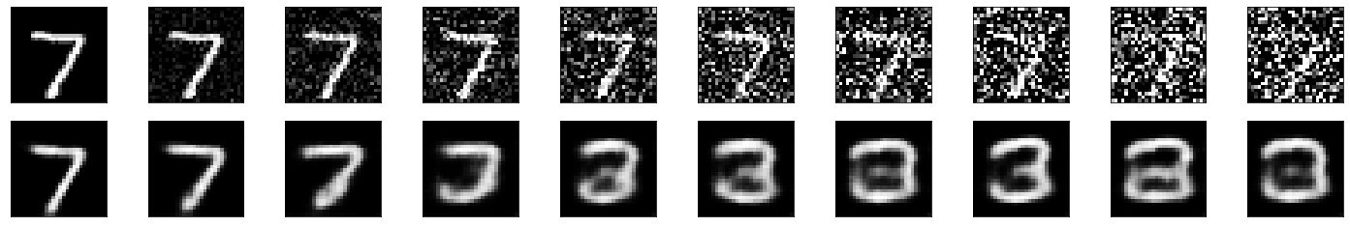

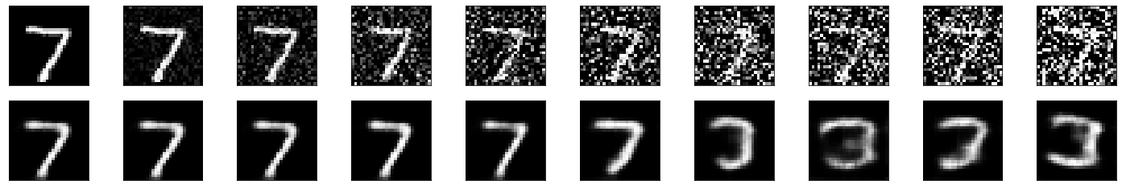

VAE:

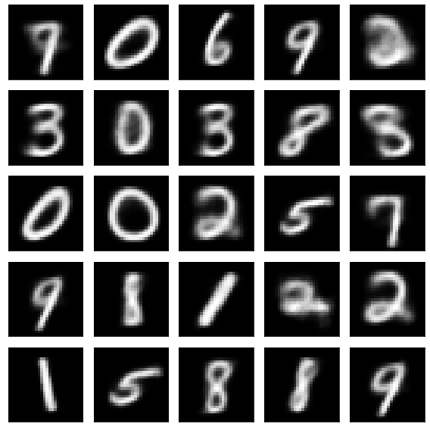

Denoise autoencoder LAB 05 min1.23

VAC LAB 05 min 1.25

Possible questions:

* What is an autoencoder?